DNA Extraction Protocol 2021

If you are new to PCR, this website may be useful to get familiar with the process and understand the biology behind the process: [PCR Setup - Brian McCauley](https://brianmccauley.net/bio-6b/6b-lab/polymerase-chain-reaction/pcr-setup)

1. **Tissue Extraction** – Cryopreservation
   1. **OPTION #1** – Liquid Nitrogen Cryopreservation (better for fewer number of samples)
      1. Materials needed for liquid nitrogen flash freezing:
         1. Mortar and pestle (Sterilized using autoclave) for each individual tissue sample collected
         2. Liquid Nitrogen (minimum of 1 L you can collect from tank at a time)
         3. Flat top microcentrifuge tubes
         4. Ethanol
      2. Prep:
         1. Have a mortar and pestle for each separate biological sample. Sterilize mortar & pestle by autoclaving. Wrap the mortar and pestle in aluminum foil and then put striped masking tape over the foil. After autoclaving, the white stripes on this tape will turn black. Autoclave for dry substances at the set 121.11˚C for 45 mins with a 15 min dry time.
         2. Liquid Nitrogen – in room R1-024. Each lab should have a personalized key.
         3. Have access to a freezer if long-term storage needed, samples can be preserved at -80C long-term.
      3. Sample Collection:
         1. Prepare a cooler box, a Styrofoam box with ice packs or other adequate freezer packaging to take with you to collect your samples and appropriately sized tubes for the type of sample you are collecting. Collect your young plant samples by looking for small younger leaves, they will be near the top of the plant. Place your collected samples in a clean tube and label your sample. Place the samples in the freezer Styrofoam box to preserve the samples immediately. After all of your samples are collected, bring the samples back to the lab for DNA extraction.
      4. Lab procedure:
         1. Place a paper towel on the counter and then the mortar and pestle on top. Spray your gloves with ethanol. You will need to clean your gloves with ethanol between every sample.
         2. Have your microcentrifuge tubes labeled with sample information and close their lids.
         3. Take your first plant sample, tear up the leaf and place the pieces in the mortar, if the leaf has a large midrib (middle stem), don’t add that in. Don’t add any non-green or faded parts of leaf to avoid any bacteria/fungi that may be growing on the plant.
         4. Quickly add the liquid nitrogen and use the pestle to grind the sample, using a circular motion. Keep going until the sample is powder like.
         5. Quickly get the first microcentrifuge tubes and dip it in the liquid nitrogen before collecting sample. Then grabbing by the lid, scoop in some of the powder sample to about halfway up the tube. Be careful that there is no liquid nitrogen inside the tube and that you are quick. If the powder sample gets wet and mushy, the sample is no longer good.
         6. After collecting the sample in the tube, close the lid properly and place it in the liquid nitrogen. Be careful if you are using the same source of liquid nitrogen that you don’t get any plant tissue inside. If there is plant sample in the stock liquid nitrogen, then it is contaminated, and you will need to get a new stock of liquid nitrogen.
         7. When you are done, you may store the samples in a -80C freezer for long-term storage or -20C freezer for short-term storage.
   2. **OPTION #2** – Geno/Grinder® (better for a large number of samples)
      1. Materials needed:
         1. Liquid Nitrogen (minimum of 1 L you can collect from tank at a time)
         2. Falcon tubes, titer plates or other suitable tubes may be used, keep your sample in mind to determine what is best. In this case, we will suppose falcon tubes (50 mL) are being used.
      2. Prep:
         1. Liquid Nitrogen – in room R1-024. Each lab should have a personalized key.
         2. Have access to a freezer if long-term storage needed, samples can be preserved at -80C long-term.
         3. Be familiar with GenoGrinder located at the farm and sample size capability. (GenoGrinder can take tubes ranging from 2mL to 75 mL).
      3. Sample Collection: same as Sample Collection above
      4. Lab procedure:
         1. Label your tubes with sample information and then place the tubes within the appropriate tube tray and load grinder balls into each sample tube. (A titer plate can be loaded with grinder balls using the ball dropper. Place the ball dropper above the titer plate and assure that there is a ball for each placeholder. Then push the cylindrical lever on the side towards the box to release the grinder balls.)
         2. Then tear up the leaf samples and place them within every tube. If the leaf has a large midrib (middle stem), don’t add that in. Don’t add any non-green or faded parts of leaf to avoid any bacteria/fungi that may be growing on the plant.
         3. Make sure the specified protocol is ready to run immediately after liquid nitrogen is added because this needs to be done as quickly as possible. The samples can be set to grind for 2 minutes at a setting of 1000 strokes per minute.
         4. Then quickly add enough liquid nitrogen to completely cover the samples.
         5. Load samples onto the GenoGrinder, close the glass cover and make sure it is securely closed and run the machine.
         6. When you are done, you may store the samples in a -80C freezer for long-term storage or -20C freezer for short-term storage.
2. **Purify the DNA -** Follow the [MagMax Plant DNA Isolation Kit](https://www.thermofisher.com/order/catalog/product/A32549#/A32549)
   * 1. McGill Market Place Item Number: A32549
   1. Disrupt the tissue – Manually following the kit
   2. “Purify the DNA Manually” using the OT-2 procedure titled “2_PLANT DNA ISOLATION MAGMAX THERMO KIT. JSON”
      1. It is recommended that you pseudo-run the protocol without samples after calibrating to make sure your calibration is accurate.
   3. Store the samples in the freezer -20C or -80C freezer for long-term storage
3. **Check the concentration of DNA -** Use the nanodrop to obtain the concentration of DNA in your purified DNA samples
   1. Click on double stranded DNA (first icon) and follow the instructions to obtain concentration values for each DNA sample.
   2. Pipette **2 uL** of Elution Buffer to calibrate the nanodrop
   3. Then pipette **2 uL** of each DNA sample to obtain DNA concentrations and record these values. Label the tubes with concentration or some indication of the sample.
      1. An example of good values is displayed in the photos below:

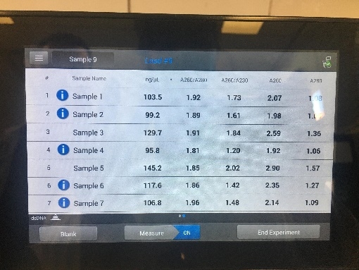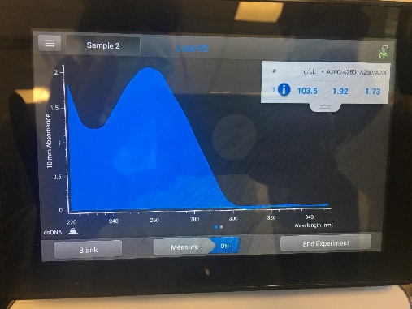

* + - 1. Good values will be greater than 30 ng/uL (first column), in the 100s would be ideal.
      2. Ideally A260/A280 and A260/A230 values will be as close to 2 as possible. These values will be re-enforced with a clear singular peak from the figure on the right.

1. **Run a control gel** – need to see standard length and results of DNA prior to running PCR
   1. Gel electrophoresis
      1. Ingredients:

|  |  |  |
| --- | --- | --- |
| Component | Molarity in 50x | Molecular weight |
| EDTA disodium salt | 50 mM | 372.24 g/mol |
| Tris | 2 M | 121.14 g/mol |
| Acetic acid | 1 M | 60.05 |

1. Preparation of a 0.5 M EDTA stock solution (500 mL)
   * + 1. Weigh out 93.05 grams of EDTA disodium salt
       2. Dissolve in 400 milliliter deionized water, shake until all is dissolved.
       3. Top up the solution to a final volume of 500 milliliters
       4. Autoclave the solution.
2. Preparation of 50x TAE buffer
   * + 1. Weigh out 242 grams of Tris-base and dissolve in approximately 700 milliliters of deionized water
       2. Carefully add 57.1 milliliters of 100 % acetic acid and 100 milliliters of 0.5 M EDTA (pH 8.0)
       3. Adjust the solution to a final volume of 1 liter, the pH of this buffer is not adjusted and should be about 8.5
       4. 1X and 50X TAE solutions can both be stored at room temperature.
3. Preparation of 1x TAE working solution
   * + 1. Add 20 ml 50 x TAE to 980 mL of distilled water to get a final volume of 1000mL 1x TA
4. 1x TAE Preparation of gel
   * + 1. Add 0.57 g of agarose (powder) in Erlenmeyer flask with 70 mL of 1x TAE dilution for 0.8% agarose gel
          1. **Note:** You need to use an Erlenmeyer flask. **Don't use a beaker**; the flask reduces evaporation and helps prevent the contents from boiling over in the next step.
          2. *(See* Extra Note (1):  *for tips on amount of agarose)*
       2. Microwave for 1 min 30 s
       3. Add 1 uL of SYBR safe DNA gel stain to mixture and mix
       4. Wrap tape around the edges of the exposed get plate and pour Erlenmeyer flask mixture onto the electrophoresis gel plate, insert the teeth, and make sure to remove any bubbles. You can do so using a pipette tip.
       5. Let the gel plate cool and harden.
       6. Put gel plate into loading dock full of loading buffer (1x TAE) such that the gel is covered completely with liquid and now it is ready to have DNA pipetted into the wells.
   1. Run DNA on gel plate
      1. Place a sheet of parafilm on a 94 well plate and slightly push the film down to create small holes over the 94 well plate
      2. Pipette **2 uL** of Orange DNA loading dye onto the wells for the number of samples that you are running.
      3. Pipette **2 uL** of DNA onto the Orange DNA loading dye and use the first level of the pipette to mix
      4. Aspirate as much of the mix into the pipette as possible without getting any bubbles in the tip. Do so by going to the second level of the pipette and slowly aspirating until all the liquid is aspirated from the parafilm.
      5. Pipette into the wells of the gel. Be careful not to go beyond the bottom of each well with the pipette tip.
   2. Process the DNA – Check for DNA presence
      1. Turn on the charges: Plug the red and black cords into the green bio rad electrophoresis cell, red in red and black in black. If it is running properly, you should see bubbles forming at the end of your electrophoresis chamber.
      * Turn on BioRad and run at 80 V
      * Set timer for 40 minutes
        + *(See* Extra Note (2): *on extra info. on how long to run the gel if you are using a different size than specified in this protocol)*
      1. After 40 minutes, remove the gel and place it into the Gel Doc EZ imager to obtain band results
         1. Pull the Gel Doc EZ imager open and place the gel on the purple tray. Then insert it into the machine.

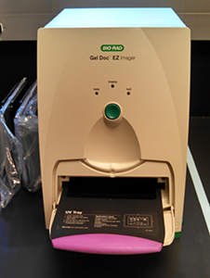

* + 1. Click on Image Lab icon on the qPCR and Gel Imaging laptop
       1. Click New protocol
       2. Under Application, hit ‘Select’ and hover over ‘Nucleic Acid Gels’, then select SYBR Safe
       3. Uncheck the box that says ‘Highlight saturated pixels’ and then hit the green ‘Run Protocol’ button on the bottom left.
       4. You should get an image produced of your bands
          1. Best results will be bright distinct bars. Stretched out or faint lines are not as good

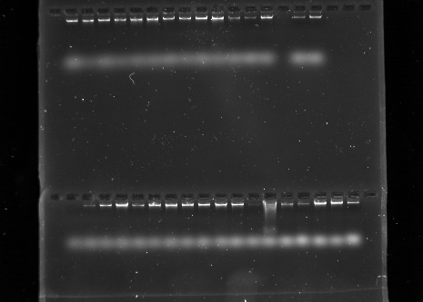

1. **Amplify the DNA** – PCR
   1. Materials needed:
      1. DNA
      2. Primers – bind to specific region that will start DNA strand at target sequence. Current primers can be found at the end at Extra Note (5): .
         1. If the primers are new, centrifuge primers for 15 sec
         2. Dilute primers
            1. (move decimal over to the right. For examples, for 18.8 nmol you add 188 microL of water)
      3. Master Mix ­­-- In this lab we use a master mix. The master mix contains 2mM standard concentration already prepared of buffer, nucleotides, and primers
         1. Taq polymerase – enzyme that binds primers to DNA
         2. Buffer
            1. **MgCl2**

***(See*** Extra Note (3):  ***for more details on the importance of MgCl2)***

* + - 1. Free nucleotides
    1. Positive and negative control to run alongside your amplified DNA.
       1. Negative control: Later in this protocol, this is the tube that is labelled with an ‘X’.
          1. This will be a reaction tube with all the PCR ingredients, minus the DNA. This tube shouldn’t produce a PCR product. If it does, it shows that one of your other ingredients was contaminated with DNA; this would mean that the results from your other tubes aren't reliable, because they might all be contaminated. This happens a lot in PCR.
       2. Positive control:
          1. A reaction tube with all the ingredients for PCR and a reliable DNA template that has been used successfully in the past (if possible). This tube should produce a PCR product. This is important in case your other PCRs don't work. If positive control works and the experimental PCRs don't, it means that the problem is with the experimental templates. If none of the tubes, including the positive control, produces any PCR product, the problem is likely to be with the other ingredients or with the PCR machine.
  1. Steps:
     1. Thaw the water and primers to RT from the freezer, thaw the PCR master mix in ice from the freezer
     2. Fill in the tables for your PCR calculations:

***\*\* Note****: Start with 1 uL of DNA 1 reaction volume and 10uM of primer concentration*

|  |  |  |  |  |
| --- | --- | --- | --- | --- |
| Reagent | Initial Concentration | Final Concentration | 1 reaction Volume | Volume for (N+1 reactions) |
| Master Mix | 2X | 1X | 6.25 uL | 81.25 uL |
| Primer F | 10 uM | 0.4 uM | 0.5 uL | 6.5 uL |
| Primer R | 10 uM | 0.4 uM | 0.5 uL | 6.5 uL |
| H20 | - | - | 4.25 uL | 55.25 uL |
| DNA | - | - | 1. uL | - |
| Final Volume for single reaction concentration: | - | - | 12.5 uL (per tube) | - |

*\*\* This is the table we used for the anthracnose primers, your values may vary*

*Initial Concentration: Concentration of stock solution.* How to calculate:

For most of the components, you can calculate the starting amount using the dilution equation: **C1V1 = C2V2**

Example Calculations:

* Master Mix:(2x)(starting volume in μl) = (1x)(12.5 μl) 🡪 starting volume 6.25 uL
* Primer: **C1V1 = C2V2** 🡪 (10 uM)(0.5 uL) = (0.4 uM) (12.5 uL)

Once you’ve figured out all the other ingredients, calculate how much water you’ll need to bring the volume up to desired final reaction volume.

* + 1. After filling in the table of your PCR calculations, get clean sample tubes for the new samples you are about to make and label them with a sharpie with information on the primer and DNA sample.
    2. Gather pipettes with the proper concentrations to pipette all the volumes from the “X Total number of reactions (volume)” column.
    3. Pipette total reaction volume of master mix, primer F, primer R, H20 and DNA into an extra control tube. Label this tube with an “X”, this will be a control tube to make sure that the DNA samples are not contaminated and reading something else other than your DNA in the gel.
    4. Vortex this mixture.
    5. Pipette 11.5 uL or whatever your final volume is for each individual tube minus the DNA into each sample tube. The same pipette can be used for this step.
    6. Then pipette 1 uL of DNA (or your chosen concentration of DNA) into each sample tube. Discard pipette between each DNA sample.
    7. Vortex all the samples and then centrifuge them (appropriate centrifuge for smaller tubes is needed.)
    8. Now these samples are ready to be run through their thermocycler protocols.

1. Machines to run PCR
   1. OT-2 Processing
      1. Create a thermocycler Protocol in the protocol designer based on the primer used. (You may need to read literature on previous experiments to get the proper thermocycler temperatures, cycles, and times for new primers being used in this lab.)
      2. Export this protocol, save it on the desktop and then import it into the OT-2 app to be run.
      3. This part of the designer is fairly straight-forward, there are examples using the anthracnose primers in the lab in the “Thermocycler PCR ” folder on the computer next to the OT-2.
      4. Run your samples with the proper thermocycler procedures in the OT-2 and then they are ready to be run on a gel.
   2. Bio-Rad CFX Connect
      1. Turn on the BIO RAD CFX Connect Real Time System and the laptop labelled “qPCR AND GEL IMAGING ONLY” that is next to it.
      2. Click on the icon “Bio-Rad CFX Maestro.
      3. On the home page, under “Select run type”, click on “User-defined”
      4. In the top left corner, you can choose “Create New…” or if your primer has been used before, click on “Select Existing…” and choose the PCR protocol saved for this primer.
      5. After clicking on “Create New…” you will open a new page that will allow you to edit for PCR parameters. Modify these parameters in accordance with the primer you are using and then click “OK”. You can click “Insert Gradient” which will be useful if you have primers with different annealing temperatures (not times) such that you can run them at the same time in this machine. The gradient slots A-H correspond to the rows in the machine.
      6. Once you hit “OK” you can save this protocol so that you can choose “Select Existing…” the next time this primer is run.
      7. This will take you back to the previous screen and you should see your PCR parameters displayed. Then click on the tab “Start Run” and click “Start Run” in the bottom right corner. The machine will run on its own and indicate to you how much time is left for you to set a timer and return for your samples later.
2. Gel electrophoresis
   1. **Note:** This will be almost identical to previous gel run, with some subtle differences in volume
   2. Preparation of gel for amplified DNA
      1. Add 0.7 g of agarose (powder) in Erlenmeyer flask with 70 mL of 1x TAE dilution for 1% agarose gel (PCR ready DNA) to use the medium sized gel. ( In the smallest gel tray that we have in the lab, 40mL with 0.4 g of agarose was a good fit.)
      2. Microwave for 1 min 30 s
      3. Add **1 uL** of SYBR safe DNA gel stain to mixture and mix
      4. Wrap tape over the edge-less sides of the gel plate and pour Erlenmeyer flask mixture onto the electrophoresis gel plate, insert the teeth and make sure to remove any bubbles
      5. Let it cool and harden.
      6. Then place into the loading dock with enough buffer solution (1x TAE) to cover the plate.
   3. Pipette DNA onto gel plate
      1. Place a sheet of parafilm on a 94 well plate and slightly push the film down to create small holes over the 94 well plate
      2. Pipette **3 uL** of Orange DNA loading dye (actual liquid colour is green) onto the wells for the number of samples that you are running
      3. Pipette **5 uL** of DNA onto Orange DNA loading dye and use the pipette to mix the two
      4. Aspirate as much of the mix into the pipette as possible without getting any bubbles in the tip
      5. Pipette into the wells of the gel
      6. **Add 2uL GeneRuler 1 kb DNA ladder** into a well as a marker for the length of DNA in the solution (no dye needed; the DNA ladder is ready-to-use)
   4. Process the DNA
      1. Turn on the charges: Plug the red and black cords into the green bio rad electrophoresis cell, red in red and black in black. If it is running properly, you should see bubbles forming at the end of your electrophoresis chamber.
      * Turn on BioRad and run at 80 V
      * Set timer for 40 minutes
      1. Then after 40 minutes, remove the gel and place it into the Gel Doc EZ imager to obtain band results
         1. Pull the Gel Doc EZ imager open and place the gel on the indented part of the tray
      2. Click on Image Lab icon on the qPCR and Gel Imaging laptop
         1. Click New protocol
         2. Under Application, hit ‘Select’ and hover over ‘Nucleic Acid Gels’, then select SYBR Safe. Make sure the tray displayed is the purple “UV Tray”. If it is not, you can click on “Custom” under Application and choose this tray.
         3. Uncheck the box that says ‘Highlight saturated pixels’ and then hit the green ‘Run Protocol’ button on the bottom left.
         4. You should get an image produced of your bands
      3. Save the image after it’s done processing
         1. Under ‘File’, click ‘Export’ and then ‘Export Publication’.
            1. On the next screen choose export at 600 psi and save the image wherever you are storing your data

**Troubleshooting:**

Common PCR problems:

Further troubleshooting: [PCR Troubleshooting Guide | Thermo Fisher Scientific - CA](https://www.thermofisher.com/ca/en/home/life-science/cloning/cloning-learning-center/invitrogen-school-of-molecular-biology/pcr-education/pcr-reagents-enzymes/pcr-troubleshooting.html?open=FalsePositive#FalsePositive)

1. Unexpected/nonspecific bands
   1. Primer Dimers
      1. **Appearance:** This results in faint bands at the bottom of the gel (along with your expected band appearing).
      2. **Cause:** This occurs when primers have complementary sequences and bind together.
      3. **Solution:** A solution to this is to reduce the amount of primers or redesign your primers
      4. A screenshot of a computer

         Description automatically generated with medium confidence
   2. Contamination
      1. **Appearance:** This results in your expected band appearing on the gel, alongside a band in another location.
      2. **Solution:** To test for contamination, run a negative control by using water instead of a DNA sample. If there is contamination in your reagents (DNA present), then you will see that unwanted band in your control. The solution is then to get fresh reagents.
      3. A picture containing text

         Description automatically generated
   3. Non-specific Binding of primer
      1. **Appearance:** May see your band at expected site and you might also see feint band at an alternate site.
      2. **Cause:** This occurs when your primer concentration is too high and it is oversaturating your template.
      3. **Solution:** Optimize your primer concentration for the best results and you can also try increasing your annealing temperature to make sure your primers are specific. You can also alter your primer sequences by increasing the length of your primers to make sure they are binding to the correct position on the template. Also be sure to avoid GC rich 3’ ends because these can result in secondary structures of the primers which inhibits them from binding to your template strand. Lastly, try scanning your template to make sure there are no alternate binding sites for your primers.
      4. Diagram

         Description automatically generated
2. Missing/no bands
   1. One band missing
      1. **Cause:** May have forgotten a reagent
      2. **Solution:** Have organized pipetting and add reagents in the same order every time. Close the tube caps after every reagent is added.
   2. All bands missing
      1. **Appearance:** You may get no bands on your gel or you may get feint bands (primer dimers) at the bottom of your gels. You may also get faint bands scattered throughout but they are not the bands you were looking for.
      2. **Solution:** 
         1. Optimize your annealing temperature. *Check* Extra Note (4): for more details.
         2. You can also try adding BSA or DMSO. BAS will prevent your reagents from sticking to the vial. DMSO will prevent any GC rich content from folding up on itself and not being able to be amplified
         3. You may also have reagents that are not fresh. Check these just in case.
         4. Double check reagent amounts (calculations).
         5. You can also try increasing the amount of PCR cycles and re-isolating your template DNA to make sure you have quality DNA to amplify.
3. Weak/faint bands
   1. **Cause:** Not a lot of DNA is amplified.
   2. **Solution:** 
      1. Add more template DNA (increase to 2uL of DNA).
      2. Try increasing the amount of PCR cycles.
      3. Increase the amount of primers being used.
      4. Lastly, increased the dNTP concentration. The standard dNTP concentration is usually around 50 uM of each nucleotide. If you have a long sequence to amplify, you may need more than 50 uM.
4. Smeared bands
   1. **Cause:** There may have been a contaminant, causing different length fragments that appear as smearing. You may also have too much template DNA. Lastly, too many cycles of PCR may have been run. Staying between 25 and 30 cycles is recommended.
   2. **Solution:**
      1. To reduce the smearing, you may try reducing the extension time and increasing the annealing temperature.
      2. You may also try changing out your TAE buffer or your voltage may be too high. Try reducing your voltage and running it for a longer amount of time to see if the smearing is improved.

Extra Note (1): Amount of Agarose needed may vary between samples. This is due to the fact that larger DNA fragments require a gel with larger pores (lower agarose percentage) or the bands will smear. Likewise, smaller DNA fragments require a gel with smaller pores (a higher agarose percentage) or the DNA will diffuse out and will appear fuzzy. Small PCR products (~200-300 bp) should have around 2% agarose. In terms of mass/volume: a 1% agarose gel will have 1g of agarose per 100 mL buffer, or 0.4g agarose/40mL buffer.

Extra Note (2): **How far to run the gel:** Without UV light, you won't be able to see the DNA while the gel runs. You'll generally want to run your DNA gels for about 15-50 minutes. There's no hard rule about how far to run your gel; you just need to run it far enough for the bands to be clearly separated. If you're only expecting one band per lane (as on some of our PCR gels), you don't need to run it far at all. For restriction digests with multiple bands, run it until the first dye front gets about halfway down the gel. Running the gel longer will separate your bands more, but it will also cause the bands to become more faint, and they could disappear completely. If you're not sure whether your gel has run long enough, you can always take it out, look at it on the UV transilluminator (as described below) and put it back to run longer.

Extra Note (3):  **MgCl2** enhances DNA **amplification by boosting the activity of Taq DNA polymerase. Mg**+ is the main cofactor for *Taq* DNA polymerase, so Mg ions bind to the catalytic site of the enzyme Taq and increase its ability to form a reaction. Additionally, MgCl2 increases the Tm of reaction. The Mg2+ ions of MgCl2 bind to the PO3–  of DNA backbone temporarily and protects the negatively charged phosphate of DNA backbone by decreasing electrostatic repulsion between DNA strands.The electrostatic repulsion between two DNA strands hinders the binding of primer to its specific location. Here the addition of MgCl2 helps in a proper binding of primer to its complementary sequence. **Note:** Generally, 1mM to 5mM concentration can be used for PCR reaction but the standard concentration is 2mM which will give the best result. Concentration more than 2mM will result in non-specific binding. As the concentration of MgCl2 increases, the chance of non-specific binding will increase. For more details click on the following link: [MgCl**2**](https://geneticeducation.co.in/role-of-mgcl2-in-pcr-reaction/)

Extra Note (4): **Change PCR parameter: Annealing Temperature**

* + PCR is based on repeated cycles of three temperatures for three steps: denaturation, primer annealing, and extension. The denaturation temperature is determined by DNA in general, and it's usually in the range 92°–98° C.  The annealing temperature depends on the primer and must be determined for each PCR. The extension temperature depends on the enzyme used; in our lab that's always Taq polymerase, and we use a 72° extension temperature.
  + Longer primers anneal more tightly than short ones, so a longer primer will have higher **melting temperature** (the temperature required to separate the primer from the template). Likewise, primers with more G-C base pairs (rather than A-T) have higher melting temperature. Thus, the melting temperature of a primer is determined by its length and GC content. The annealing temperature used in PCR must be lower than the melting temperature by 5° or so. Each PCR has one annealing temperature (you can't have different temperatures for the two different primers), so it's important that the two primers have similar melting temperatures and annealing temperature is within 5° of both.
    - So what we can change is the annealing temperature specific to a primer.
    - Annealing Time:
      * Check the primer specification sheet and adjust the annealing time to be slightly below the melting temperature of the Forward and Reverse Primer
      * (One can increase the specificity of PCR by using a higher annealing temperature in the first ten cycles (+2 °C) and lowering the Ta in the following 20 to 30 cycles (-5 °C). This touchdown method improves both specificity and yield)
  + 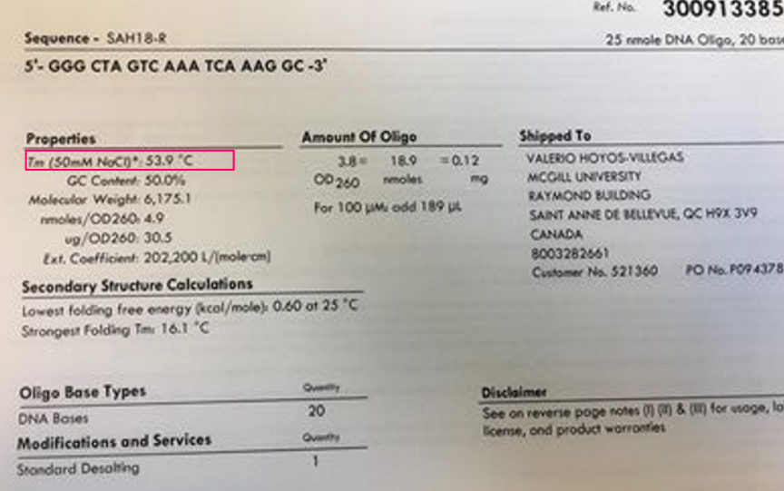

Extra Note (5): **Primers we have in the VHV lab**:

|  |  |  |
| --- | --- | --- |
| NDSU_IND_1_50.2219 | Indel Marker (Co-1) |  |
| [Resem, m,arch – BeanCAP (uprm.edu)](http://arsftfbean.uprm.edu/beancap/research/) | Forward | CTCAAGAACCTGCAACAAACACCAAA |
|  | Reverse | AAGGGTGTAGTTGGGGGTATAAGTGGTG |
| SAH18 | SCAR marker (Co-3) |  |
| [Unbekannt (springer.com)](https://link.springer.com/content/pdf/10.1007/s10681-005-7075-x.pdf) | Forward | GGGCTAGTCAGACTGATTCT |
|  | Reverse | GGGCTAGTCAAATCAAAGGC |
| SAS13 | SCAR marker (Co-4^2) |  |
| [PDF (usda.gov)](https://naldc.nal.usda.gov/download/IND23284424/PDF)  [(14) (PDF) Marker-assisted dissection of the oligogenic anthracnose resistance in the common bean cultivar, ‘G2333’ (researchgate.net)](https://www.researchgate.net/publication/227084228_Marker-assisted_dissection_of_the_oligogenic_anthracnose_resistance_in_the_common_bean_cultivar_%27G2333%27) | Forward | CACGGACCGAATAAGCCACCAACA |
|  | Reverse | CACGGACCGAGGATACAGTGAAAG |
| SAB3 | SCAR maker (Co-5) | 400 bp |
| [PDF (usda.gov)](https://naldc.nal.usda.gov/download/IND23284426/PDF) | Forward | TGGGGCACACATAAGTTCTCACGG |
|  | Reverse | TGGCGCACACCATCAAAAAAGGTT |